Chemistry

Unit 2
Classifying Matter

Set 6.0: Physical Changes

Skill 6.01: Describe the three most common states of matter
Skill 6.02: Identify the physical transformations that exists between three most common states of matter
Skill 6.03: Describe the energy changes that accompany physical transformations
Skill 6.04: Define endothermic and exothermic
Skill 6.05: Use energy diagrams to represent physical transformations

Skill 6.01: Describe the three most common states of matter

Skill 6.01 Concepts

You are already familiar with the three most common states of matter: solid, liquid, and gas (vapor). Some properties of each are summarized below:

Solid | Definite shape, definite volume, the molecules vibrate in fixed positions
Liquid | Definite volume, no definite shape, the molecules can slide past one another
Gas | No definite volume, no definite shape, the molecules are very far apart

Skill 6.01 Example 1
Which of the following would be best classified as a solid? A liquid? A gas?
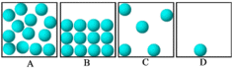

Skill 6.02: Identify the physical transformations that exists between three most common states of matter

Skill 6.02 Concepts

A physical transformation of a pure substance is one that leaves it as the same substance but in a different state. The most common physical transformations are described below:

Vaporization | Process of going from a liquid to gas
Condensation | Process of going from a gas to liquid
Freezing | Process of going from a liquid to solid
Melting | Process of going from a solid to liquid
Sublimation | Process of going from a solid to gas
Deposition | Process of going from a gas to solid

Skill 6.02 Example 1
Each box shown contains a single atom or a sample of atoms. The atoms in all the boxes are identical. Which transition from one state to another best represents:
a. melting
b. freezing
c. evaporating
d. condensation
e. sublimation

Skill 6.03: Describe the energy changes that accompany physical transformations

Skill 6.03 Concepts

When physical transformations occur, energy is always transferred. The following demonstration is illustrative.

Data collection

Wet your right hand with substance A (note what you feel)
Wet your left hand with substance B (note what you feel)

Skill 6.03 Example 1
- What happened to the liquids on your hands?

- Did energy enter or leave the liquid during this process? How do you know?

- Did energy enter or leave your skin during this process? How do you know?

Skill 6.04: Define endothermic and exothermic

Skill 6.04 Concepts

The terms endothermic and exothermic are often used to describe energy changes. When energy is absorbed, that is the transformation requires energy, the process is said to be endothermic. When energy is released, the process is exothermic.

Endothermic | Energy is absorbed | The change in energy is assigned a positive value, +⬇E
Exothermic | Energy is released | The change in energy is assigned a negative value, -⬇E

Skill 6.04 Example 1
Was the process of the liquids leaving your skin an endothermic or an exothermic process?

Skill 6.04 Example 2
Each box shown contains a single atom or a sample of atoms. The atoms in all the boxes are identical. Which transition from one state to another:
- Is most endothermic?
- Is most exothermic?

Skill 6.05: Use energy diagrams to represent physical transformations

Skill 6.05 Concepts

Energy diagrams are a graphical way to visualize changes in energy.

H₂O(gas)

energy
⬇E>0

H₂O(liquid)

The energy diagram shows the differences in energy, ⬇E, before and after the change. Notice that because ⬇E>0, the final energy value is greater than the initial energy value. Therefore energy was required to bring about the indicated change.

Skill 6.05 Example 1
Each circle in the figure represents a molecule of water.
- If a container of water was cooled from 50ºC to -20ºC, which transition would be most favorable? Draw an energy diagram to represent this transition.

- If a container of water was heated from -20ºC to 25ºC, which transition would be most favorable? Draw an energy diagram to represent this transition.
- If a container of water was heated from -20ºC to 120ºC, which transition would be most favorable? Draw an energy diagram to represent this transition.

Set 7.0: Chemical Changes and Matter

Skill 7.01: Distinguish between chemical and physical changes at the observational, symbolic, and molecular representational levels
Skill 7.02: Classify matter as a pure substance or mixture
Skill 7.03: Classify a mixture as homogenous or heterogeneous at the observational and molecular levels.
Skill 7.04: Classify a pure substance as either an element or compound at the symbolic and molecular representational levels
Skill 7.05: Describe how to separate a mixture given its physical properties

Skill 7.01: Distinguish between chemical and physical changes at the observational, symbolic, and molecular representational levels

Skill 7.01 Concepts

We have already discussed physical changes. A physical change of a pure substance is one that leaves it as the same substance but in a different physical state. The bonds holding the atoms together in the original compound(s) are NOT broken.

An example of a physical change is the change from one state to another. For example when water evaporates it remains water. This transformation can be represented as follows:

H₂O(l) → H₂O(g)

A chemical change is one that changes the identity of the substance. Bonds are either broken or formed between atoms.

An example of a chemical change is the formation of water. This change can be represented in at least 3 different ways. The first way is the observational level: as one reacts hydrogen and oxygen, one can see the evolution of heat and light. These are both indicators of chemical change. The second way is the symbolic level: one can write a chemical equation that represents the process.

O₂(g) + 2H₂(g) → 2H₂O(l)

The third way is at the molecular level: one can draw molecules to represent the process:

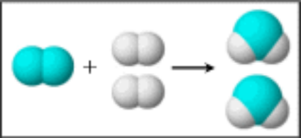

Skill 7.01 Example 1
(i) Classify each of the following as physical or chemical
(ii) Draw picture to represent each process.
(a) water evaporating

(b) water melting

(c) magnesium (Mg) burning in oxygen gas (O₂) to form magnesium oxide (MgO)

(d) Water decomposing to form hydrogen gas (H₂) and oxygen gas (O₂)

Skill 7.01 Example 2
Classify each of the following as physical or chemical
(a)
+
+

(b)

(c) S₂(s) + 2Zn(s) → 2ZnS(s)
(c) NaCl(s) → Na⁺(aq) + Cl⁻(aq)
(d) CO₂(s) → CO₂(g)

Skill 7.02: Classify matter as a pure substance or mixture

Skill 7.02 Concepts

Matter is “stuff” – matter has mass, occupies space, and has energy

Matter can be divided into two broad types: pure substances and mixtures

In a pure substance, only a single type of matter is present. In other words, only a single element or compound is present.

In a mixture, two or more pure substances are mixed.

Skill 7.02 Example 1
Classify the following as either a pure substance or mixture:
- water | - sand | - sugar and water | - sugar

Skill 7.03: Classify a mixture as homogenous or heterogeneous at the observational and molecular levels.

Skill 7.03 Concepts

Mixtures can be further subdivided into two groups: homogeneous mixtures and heterogeneous mixtures (figure 1)

A homogeneous mixture is uniform throughout. Another name for a homogeneous mixture is a solution.

A heterogeneous mixture is not the same throughout. The individual constituents are visibly distinguishable.

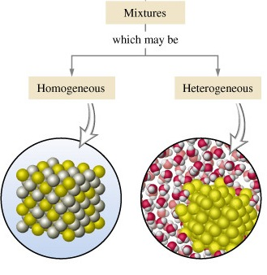
Figure 1. Homogeneous and heterogeneous mixtures

Skill 7.03 Example 1
Which of the following could be classified as solutions?
- Food coloring and water | - salt and pepper | - pepper and water | - oil and water

Skill 7.03 Example 2
Refer to the illustration below to answer the following.
(A) 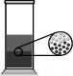 (B) 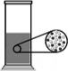
(C) 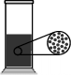 (D) 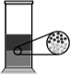

- Which drawing or drawings represents a heterogeneous mixture? (Explain)

- Which drawing or drawings present a homogeneous mixture? (Explain)

- Which drawing best represents the mixture that results when oil is added to water? (Explain) (The light circles represent water molecules, and the dark circles represent oil molecules.)

- Food coloring is added to water to make a solution. Which drawing will best represent the solution? (Explain) (The light circles represent water molecules, and the dark circles represent food coloring molecules.)

Skill 7.04: Classify a pure substance as either an element or compound at the symbolic and molecular representational levels

A pure substance can be classified as either an element or a compound.

Elements are the basic building blocks of matter. Examples include, Ag, Na, O₂, S₈

Compounds are pure substances made from two or more different elements.
The symbol for a chemical compound contains the symbols that represent the elements along with the how many of each element.

C₁₂H₂₂O₁₁ for example, contains 12 carbons, 22 hydrogens, and 11 oxygens

Skill 7.04 Example 1
Which of the following are compounds?
- iron oxide Fe₂O₃
- table salt - sodium chloride (NaCl)
- sucrose (C₁₂H₂₂O₁₁)
- Carbon (C₆₀)
- Phosphorous (P₄)

Skill 7.04 Example 2
Refer to the illustration below to answer the following.
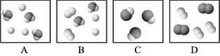
- Which figure or figures best represents a mixture of two pure substances?

- Which figure or figures best represents a pure substance?

Skill 7.05: Describe how to separate a mixture given its physical properties

Skill 7.05 Concepts

A useful schema for classifying a substance as a heterogeneous mixture, a homogeneous mixture, element, or compound is given below.
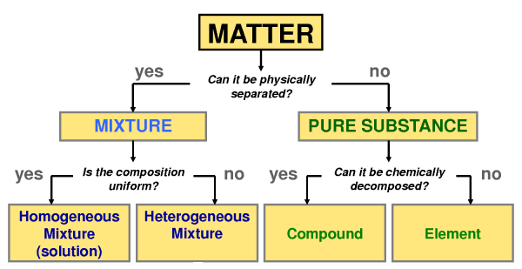
Figure 2. Classification of matter

According to the figure above, the fundamental difference between pure substances and mixtures is the ability to separate the components using physical means. If a substance can be separated by physical means it is classified as mixture; if it cannot, it is classified as a pure substance. Two techniques that can be applied to separate the components of a mixture are described below.

Separation by filtration

Recall that heterogeneous mixtures have particles that are visibly distinguishable (think toppings a pizza) or sand in water.

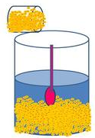
Figure 3. Sand and water

A technique for separating insoluble components from a liquid is filtration. Filtration is a mechanical or physical process applied to separate insoluble particulates from a liquid. For example many acids dissolve iron but not gold. Thus if we put our mixture into an appropriate acid, the acid would dissolve the iron and the gold would be left behind. The two could then be separated by filtration (figure 1)

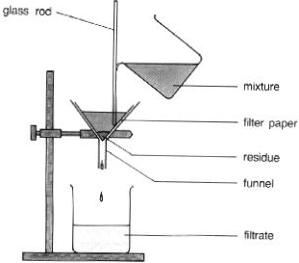
Figure 4. Filtration procedure

Separation by evaporation

Evaporation is another useful technique for separating a mixture. This process is illustrated below (Figure 5). When the salt water solution is heated, the water evaporates, leaving the salt behind.

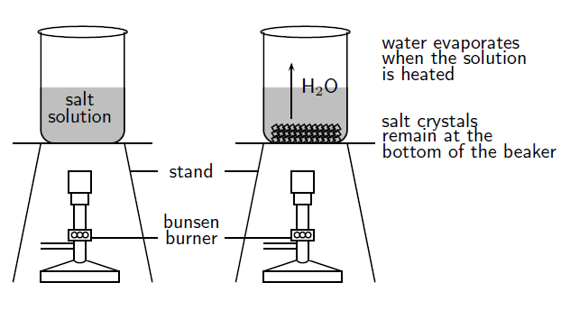

Skill 7.05 Example 1
Use the information below to propose a method for separating out a mixture of sand, salt, and sugar.

 | Sand | Salt | Sugar
Ethanol | Insoluble | Insoluble | Soluble
Water | Insoluble | Soluble | Soluble

Set 7.0 Practice Problems

- Identify whether each of the following is a heterogeneous or homogeneous mixture. For each mixture, draw a picture to represent the arrangement of the atoms.

(a) sugar and pepper

(b) pepper and water (pepper is insoluble in water)

(c) sugar and water

(d) brass (copper and zinc)

- Which of the following are compounds: baking soda (NaHCO₃), graphite (C), dry ice (solid CO₂), sodium (Na), Sulfur (S₈), Nitrogen (N₂)

- Which of the following represent chemical changes, how do you know?

- C₃H₆O(l) → C₃H₆O(g)

- C₁₂H₂₂O₁₁(s) + O₂(g) → CO₂(g) + H₂O(l)

- CO₂(s) → CO₂(g)

- S₈ + O₂ → SO₂

- NaHCO₃ → NaO + CO₂ + H₂O

- Classify each of the following changes as chemical of physical

(a) wood turning into paper

(b) food coloring dissolving into water

(c) hydrogen and oxygen forming water

- Describe a procedure for separating a mixture of sand, salt, and water

- Use the information below to propose a method for separating out a mixture of sand, salt, sugar, and iron.

 | Sand | Salt | Sugar | Iron
Ethanol | Insoluble | Insoluble | Soluble | Insoluble
Water | Insoluble | Soluble | Soluble | Insoluble
Attracted to a magnet | No | No | No | Yes

